# Industrial Training Report

## (July 2021 – September 2021)

**General Awareness of Steam Turbine Manufacturing**

Submitted in partial fulfilment of the requirements of

FIVE YEAR DUAL DEGREE B-TECH +M-TECH

**Mechanical Engineering**

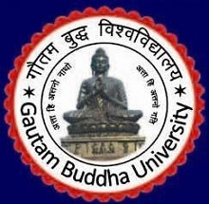

**GAUTAM BUDDHA UNIVERSITY**

(201312)

**Submitted By:**

Name- Abhishek Kumar

Reg No.- 202100190